**Rutas de instalación del Python**

Donde se instala Python: en cmd, poner:

**where python**

En mi pc: C:\Users\iretuerto\AppData\Local\Programs\Python\Python38\python.exe

donde se crean los entornos virtuales de Python3

**c:\windows\system32\venv_rasa\lib\site-packages**

el modelo básico se crea aquí cuando se instala rasa:

**c:\windows\system32**

**Desintalar rasa**

<https://rasa.com/docs/rasa/installation/>

**Desintalar rasa --> pip3 uninstall rasa**

**borrar entornos virtuales (ej: venv)**

desactivar el entorno cuando se está dentro:

**deactivate**

ir a la ruta, elegir el venv y borrar la carpeta:

**c:\windows\system32\venv_rasa\lib\site-packages**

**Instalación RASA**

ATENCIÓN: entrar en el cmd como administrador!!



- Creamos entorno virtual

**python -m venv ./venv**

- Entrar en el entorno creado en la instalación

**.\venv\Scripts\activate**

- Actualizar pip:

**python -m pip install --upgrade pip**

- Instalamos RASA en el entorno virtual creado. Para que funcione ‘rasa x’ debe ser menor que 3.0.0

(**pip3 install rasa==2.8.33)**

**pip3 install rasa==2.8.26** (versión contrastada)

- Arrancar / parar rasa

**rasa init**

**/stop**

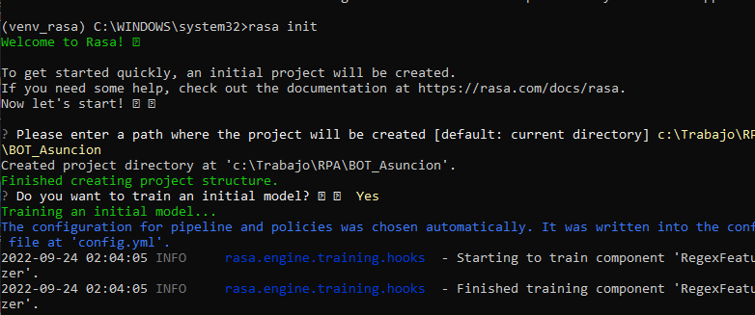

<https://rasa.com/docs/rasa/installation/>

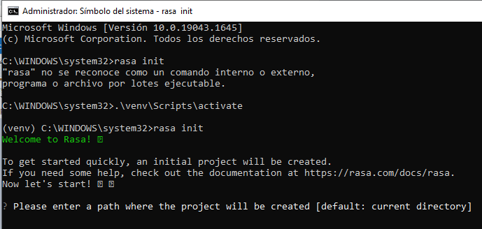

**PARA PROBAR FORMATOS DE FICHEROS YML**

[**https://yamlchecker.com/**](https://yamlchecker.com/) **to validate the YAML syntax of your file.**

Documentación útil

<https://rasa.com/docs/rasa/training-data-format#training-examples>

Summary#

Once you've done the following, you can train your bot and try it out!

Add RulePolicy to your policies and ResponseSelector to your pipeline in config.yml

Add at least one rule for responding to FAQs/chitchat

Add examples for your FAQs/chitchat intents

Add responses for your FAQs/chitchat intents

Update the intents in your domain

Now, your assistant should be able to respond correctly and consistently to FAQs or chitchat, even if these interjections happen while your assistant is helping the user with another task.

**UNA VEZ CAMBIADOS TODOS LOS FICHEROS DEL BOT**

<https://rasa.com/docs/rasa/command-line-interface/>

1- Nos movemos al directorio en el que está la estructura del proyecto

(venv) C:\WINDOWS\system32> cd C:\Trabajo\RPA\Project Hospital

rasa run -m models --credentials credentials.yml --enable-api --log-file out.log --endpoints endpoints.yml

2- rasa train : aplica cambios de los ficheros

3- rasa test: comprueba los test ideados

4- rasa run: ? Para parar: crtl+c

5- rasa shell: Loads your trained model and lets you talk to your assistant on the command line.

----------------------

rasa init Creates a new project with example training data, actions, and config files.

rasa train Trains a model using your NLU data and stories, saves trained model in ./models.

rasa interactive Starts an interactive learning session to create new training data by chatting to your assistant.

rasa shell Loads your trained model and lets you talk to your assistant on the command line.

rasa run Starts a server with your trained model.

**rasa run actions** Starts an action server using the Rasa SDK.

rasa visualize Generates a visual representation of your stories.

rasa test Tests a trained Rasa model on any files starting with test_.

rasa data split nlu Performs a 80/20 split of your NLU training data.

rasa data convert Converts training data between different formats.

rasa data migrate Migrates 2.0 domain to 3.0 format.

rasa data validate Checks the domain, NLU and conversation data for inconsistencies.

rasa export Exports conversations from a tracker store to an event broker.

rasa evaluate markers Extracts markers from an existing tracker store.

rasa x Launches Rasa X in local mode.

rasa -h Shows all available commands.